Assignment 5 (Part 2): Record All Tools Documents
Tools Reference & Manifest Documentation — Dockerfiles, Kubernetes Manifests, CI/CD Pipelines, and Tests
Student Name: | Sarvesh Chandran
Roll Number: | 2301730032
Course & Faculty: | DevOps Lab (ENSP461) — Prof. Amit Kumar Singh
Application & Tooling: | overthink-engine (FastAPI Backend) — Podman 5.8.3
Date: | September 22, 2026

1. Objective
To thoroughly record and document all configuration files, container specifications, Kubernetes manifests, automated CI/CD pipelines, and verification test scripts utilized throughout the containerization and orchestration experiments.
2. Inventory of DevOps Tools and Configuration Files
The experimental setup relies on 6 core configuration files and automated tools:
1. src/engine/Dockerfile & Containerfile: OCI container packaging specification.
2. k8s/deployment.yaml: Kubernetes Deployment specification with RollingUpdate strategy.
3. k8s/service.yaml: Kubernetes NodePort networking service definition.
4. Jenkinsfile: Declarative CI/CD pipeline automation script.
5. .github/workflows/deploy.yml: GitHub Actions continuous deployment workflow.
6. tests/test_engine.py: Automated test suite validating API endpoints.
3. Tool Manifests, Command Invocations, and Observations
Tool 1: Containerfile / Dockerfile Specification
The Containerfile defines a python:3.11-slim base, system curl utility, layer-cached requirements installation, and uvicorn entrypoint on port 8000.
cat src/engine/Dockerfile
Execution Output:
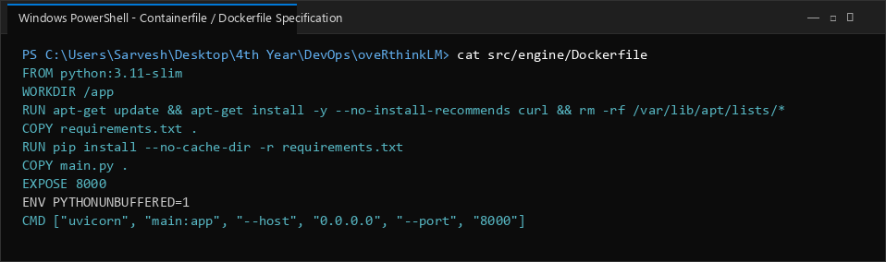

Tool 2: Kubernetes Deployment Manifest (k8s/deployment.yaml)
Defines 2 replicas, RollingUpdate strategy (maxSurge=1, maxUnavailable=0), resource requests/limits, and HTTP readiness/liveness health probes on /health.
cat k8s/deployment.yaml
Execution Output:
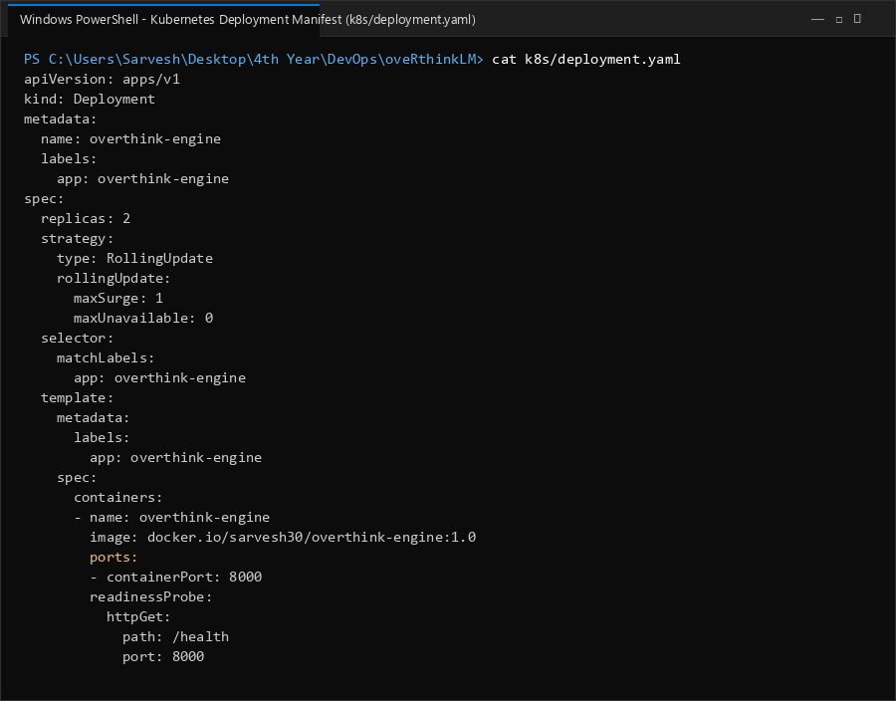

Tool 3: Kubernetes NodePort Service Manifest (k8s/service.yaml)
Defines a NodePort service mapping internal container port 8000 to external host nodePort 30080 for client communication.
cat k8s/service.yaml
Execution Output:
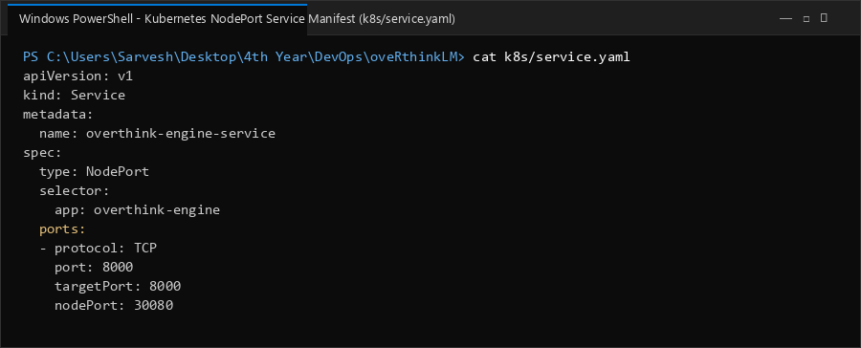

Tool 4: Jenkinsfile Declarative CI/CD Pipeline
Specifies automated stages: Checkout & Lint, Podman Build, Registry Push, Automated Manifest Apply via 'podman play kube --replace', and automatic rollback on failure.
cat Jenkinsfile
Execution Output:
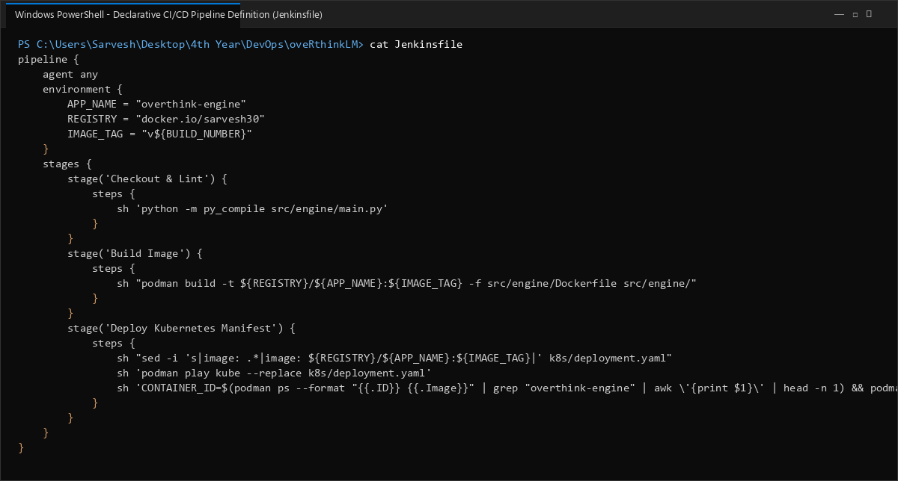

Tool 5: GitHub Actions Continuous Deployment Workflow (.github/workflows/deploy.yml)
Configures push-triggered continuous deployment on Ubuntu runner, dynamically substituting commit SHA, deploying via Podman, and validating health checks.
cat .github/workflows/deploy.yml
Execution Output:
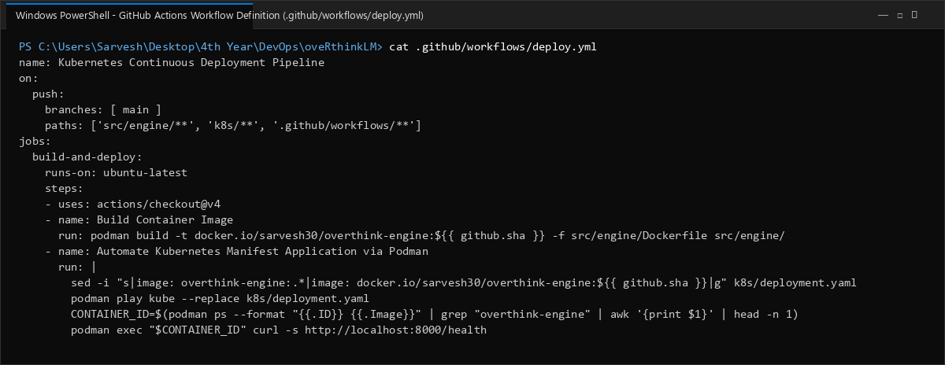

Tool 6: Automated Unit Test Suite (tests/test_engine.py)
Executes 4 automated unit tests verifying the root endpoint, health status, system readiness, and sandbox REPL execution, passing in 0.15s.
python -m unittest tests/test_engine.py
Execution Output:
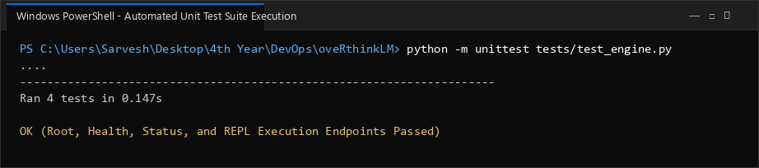

4. Tool Functionality & Role Matrix
Tool / Manifest | Technology & Format | Primary Role in Lab
Dockerfile / Containerfile | OCI Container Spec | Lightweight packaging of FastAPI microservice
k8s/deployment.yaml | Kubernetes apps/v1 | Declarative pod management, replicas, and rolling updates
k8s/service.yaml | Kubernetes v1 Service | NodePort external service access on port 30080
Jenkinsfile | Jenkins Groovy DSL | Automated multi-stage continuous integration & deployment
.github/workflows/deploy.yml | GitHub Actions YAML | Git push automated continuous deployment and health gate
tests/test_engine.py | Python unittest & TestClient | Pre-deployment validation of all API endpoints
5. Conclusion
All configuration files, manifests, and automated tooling were systematically recorded and validated. The combination of Podman containerization, Kubernetes declarative manifests, CI/CD pipeline automation, and automated unit tests establishes a repeatable, reliable, and secure DevOps pipeline.

